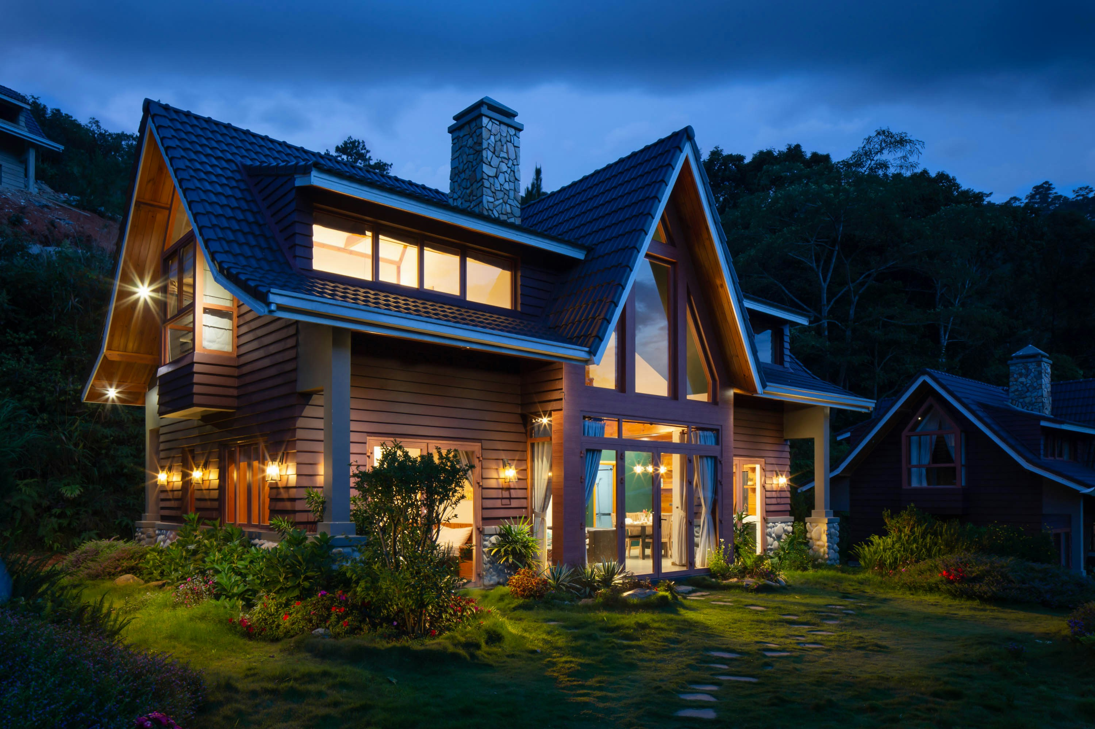

This home offers versatility for all, making it an ideal place to raise a family at any life stage. Featuring two expansive living areas plus a flexible rumpus room accessed through double doors, a well-appointed kitchen, and a meals area seamlessly transitioning to the entertaining deck, the home's foundational elements include a palette of calming neutral tones and breathtaking views revealed through floor-to-ceiling windows.

You'll love creating culinary delights in the well-configured kitchen where conversation will flow effortlessly around the breakfast bench. Stainless-steel appliances, such as the Whirlpool 900mm oven/cooktop, Bosch dishwasher, and walk-in pantry, ensure convenience in everyday life.

* 5 Bedrooms
* 2 Bathrooms
* Amazing open-plan kitchen living
* Impressive Outdoor entertaining area
* Below ground pool
* Large 1 acre block
* Close to great schools

**$800,000**

**Features.**

**Contact:** Bev 0440 123 123 - bevwhitehall@gmail.com.au

For

**123 SMITH STREET, MELBOURNE.**

**Sale**